To Do in DM 5.0

Introduction
In DM 4.x the To Do items are created for critical alerts. The following functionality is supported for the To Do list:
- The following columns are shown in To Do List grid
  - Done – customer can click on this cell to mark a task completed.
  - Server – server for which a critical alert was raised.
  - Description – description of the alert.
  - Comments – editable field where the customer can enter comments.
  - Date – date/time when the alert was raised.
- A To Do item can be deleted – this does not clear the alert.
- A To Do item can be set to fixed or complete, by clicking on the “Done” column for the item in the grid.
- A comment can be entered for a To Do item by editing the “Comments” field.
- A To Do item can be double-clicked to navigate to the associated window. In some cases SQLdm cannot provide additional information about the error, in which case no window is displayed.
- The To Do List grid supports the following functionality
  - Print
  - Export – Excel or text file (customer can specify delimiter)
  - Refresh

DM 5.0
A To Do item is created for an Alert by configuring the Alert notification. To Do item can be assigned to a user (it is just a text field, not associated with any Windows user).
The UI specification has details about what has to be implemented for To Do. To simplify the implementation of this feature, the following changes are being proposed.

Feature Changes
- The Task will be renamed to To Do, this is to be compatible with DM 4.x.
- The following items will not be supported
  - Ability to manually create To Do items
  - Properties : Due Date, % Complete, and Created By

Repository Table
The Repository ToDo table will consist of the following columns:
- TaskID
- Instance (is currently ServerName)
- Subject
- Message
- CreatedOn (is currently TaskCreated)
- Metric
- State (i.e. severity)
- Value
- EventID
- Status – Not Started, In Progress, Completed, Waiting on Someone, On Hold
- Comment (new field)
- Owner (is Assigned)
- CompletedOn (new field) – get set to the current time when Status is changed to Completed

The following fields can be edited by the customer:
- Status
- Owner
- Comment
- CompletedOn (because of changing the Status field)

Remove the following columns from the table.
- PercentComplete
- CreatedBy
- DueDate
- Priority

UI
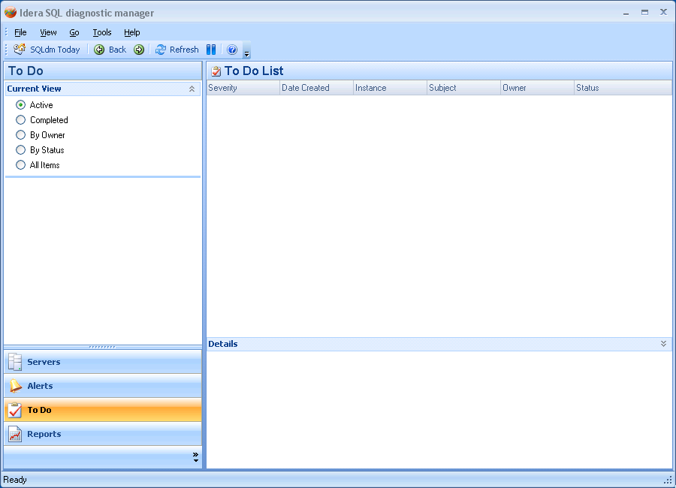
The UI mockup for To Do feature is shown above. In addition to what is shown above, there will be a filter option which will look something this.
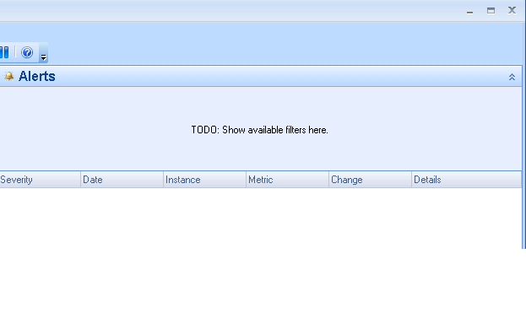

To Do View
This has three panes in this view.
- Collapsible filter pane at the top
- Grid pane in the middle
- Collapsible Details pane at the bottom

Filter Pane
The Filter pane comes first, this is a collapsible pane. The following filter options will be supported:
- State (i.e. severity)
        - Any (default)
        - Warning
        - Critical
- Instance
        - Any (default)
        - Select SQL Server
- Owner
        - Any (default)
        - Specific owner
- Status
        - Any(default)
        - Not Started
        - In Progress
        - Completed
        - Waiting on Someone
        - On Hold
        - Not Completed (special case)
- Show items for last N days

Only one value can be selected for each of the filter options

Grid Pane
The grid view will display the following columns, we may choose lesser columns if space becomes an issue.
- Severity
- Date Created
- Instance
- Subject
- Comments
- Owner
- Status

The grid will support the following:
- Column sorting
- Grouping
- Column selection (Rider)
- Print – match with the other grids
- Export to excel file– match with the other grids

The grid will have the following context menu items:
- Mark as Complete – sets Status of selected Task to Completed (multi-select???)
- Assign Task – changes owner (multi-select???)
- Delete – multi-select???

Details Pane
This is a collapsible pane. Here information for the selected item in the Grid pane will be shown. This pane will contain the following stuff:

- To Do item details
- Support modifying Status, Owner and Comment fields.
- Ability to go to views for diagnosing the underlying alert.

Navigation Pane
The following views are supported. Note that a selected view will affect one or more options in the Filter pane. The filter options changed by a view selection are noted with each view listed below. The modified filter will be applied to collect the data from the Repository.
For example, the filter options have been set to Status (All), State (All), Owner (Any) and Last 7 days. If the user clicks on the Active view then the Status filter option will be set to “Not Completed”, the other options remain the same. The query to the Repository will use the new filter.

Active
This view will be selected by default. This view displays all To Do items with Status not set to Completed. When this view is selected the filter option Status will be set to “Not Completed”, all other options remain the same.

Completed
This view displays all To Do items with Status set to Completed. When this view is selected the filter option Status will be set to “Completed”, all other options remain the same.

By Owner
This view displays all To Do items grouped by Owner column. The filter options do not change.

By Status
This view displays all To Do items grouped by Status column. The filter options do not change.

All
This view displays all To Do items. The filter options do not change.

